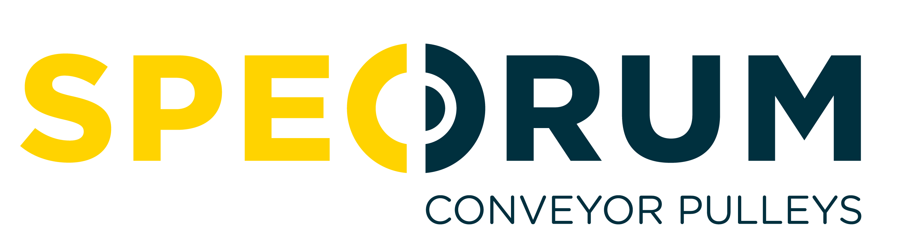
JOB DESCRIPTION

JOB TITLE: Maintenance Technician

REPORTING TO: Maintenance Supervisor

JOB PURPOSE: To assist in providing an effective maintenance service by completing general maintenance of plant, equipment and facility improvements.

KEY RESPONSIBILITIES:

- Maintain a planned servicing and preventative maintenance programme across the site.
- Respond to breakdowns & complete repairs in timely manner taking account of production schedules.
- Make periodic inspections of equipment to find defects before breakdowns occur.
- Diagnose problems and then complete repair or arrange replacement as required.
- Diagnose & replace faulty mechanical, hydraulic & pneumatic components of machines &equipment.
- Liaise with Purchasing Team regarding the purchase of necessary materials from approved suppliers at best price.
- Communicate with production supervisors and keep them updated on the progress of repair jobs.
- Comply with Health, Safety & Environmental requirements and assist with the implementation of company procedures and standards.
- Keep Maintenance Supervisor advised of plant, machinery and equipment failures that require production downtime for maintenance work.
- Ensure all servicing and maintenance records are maintained.
- Any other duties, within reason and capability, as agreed with the Maintenance Supervisor & General Manager.

PERSON SPECIFICATION
Qualifications & Qualifications relevant to Mechanical or Electrical systems, installation or repair
Experience: would be an advantage, including vehicle/ motor repairs.
Experience in general facility maintenance is also beneficial e.g. installing notice boards, wall fixtures etc.

Skills, Competencies: Effective organisation, planning & time management ability
& Circumstances Ability to demonstrate accuracy & efficiency in work tasks
Exceptionally well developed interpersonal & communication skills
Desire to own decisions and take responsibility
Self-motivated, enthusiastic team player
Willingness to work flexible hours

