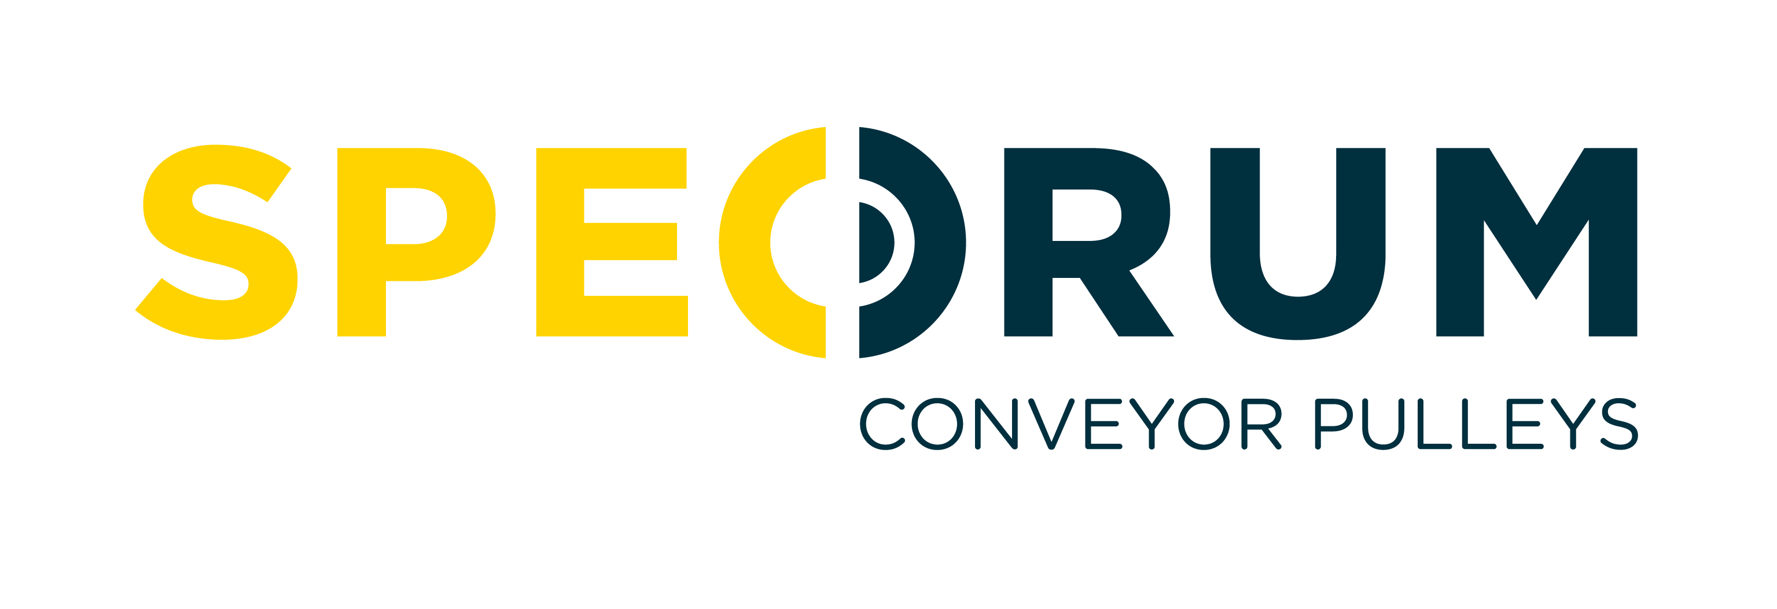

JOB DESCRIPTION

JOB TITLE: Human Resources Officer

REPORTING TO: Human Resources Manager

JOB PURPOSE To operate and maintain efficient and effective transactional Human Resources (HR) activities and implement policies & procedures to successfully achieve the company’s business targets and meet legislative requirements.

KEY DUTIES & RESPONSIBILITIES:

• Maintain necessary employee records, in accordance with legislative requirements, for effective
communication with all employees, across all business functions.
• Resolve day-to-day employee queries and provide appropriate information.
- Maintain absence management records and monitor compliance with absence & timekeeping procedure.
- Be actively involved in recruitment process by preparing job descriptions and person specifications, preparing advertisements, posting ads etc. to achieve appointment of the right person for the job.
- Maintain the Apprenticeship Programme and school engagement activities via MEGA.
- Plan and source training to encourage employee development, assist in delivering training, including inductions for new employees and maintain training records.
- Support the management of grievance and disciplinary issues according to company policy.
- Work closely with line managers/supervisors, assisting them to understand and implement policies and procedures and relevant employment legislative changes.
- Support the development & implementation of HR initiatives to gain employee engagement and to attract & retain employees e.g. Health & Wellbeing Programme, Health Insurance, Bonus allowances etc.
- Work with the HR Manager to develop HR strategies, to consider immediate and long-term employee requirements in terms of numbers, skill sets & benefits.
- Assist with implementing performance conversations and support managers/supervisors in maintaining records and reviewing agreed development goals.
- Work with the managers & supervisors to progress continuous improvement projects across all business areas, particularly the HR projects, to achieve agreed business targets.
- Review existing HR policies & procedures in line with business requirements and develop of any necessary new policies and procedures.
- Keep HR Manager informed of ongoing matters, provide updates and reports for Senior Management and advise on how employment law can be met to ensure company compliance.
- To promote equality & diversity as part of the company’s culture and help ensure HR adds value to the company.
- Any other duties, within reason and capability, as agreed with the HR Manager/ Senior Managers

Person Specification
Criteria | Essential | Desirable
Qualifications & Relevant Experience | • 2+ years recent experience in a HR role  - CIPD Level 5 Certificate in HR Management | Experience working in a manufacturing environment
Skills, Knowledge & Competencies | • Strong working knowledge of HR legislation  - Excellent communication & organisational skills  - Demonstrated ability to deliver HR solutions in partnership across a broad range of functions  - Persuasive, analytical and problem-solving skills  - Confidentiality & sensitivity when required.  - Proficient in use of MS Office applications | Knowledge of employee resolution strategies and on how to best represent the company at tribunals.
Circumstances | • Self-motivated, enthusiastic team player  - Desire to own decisions and take responsibility

