JOB DESCRIPTION
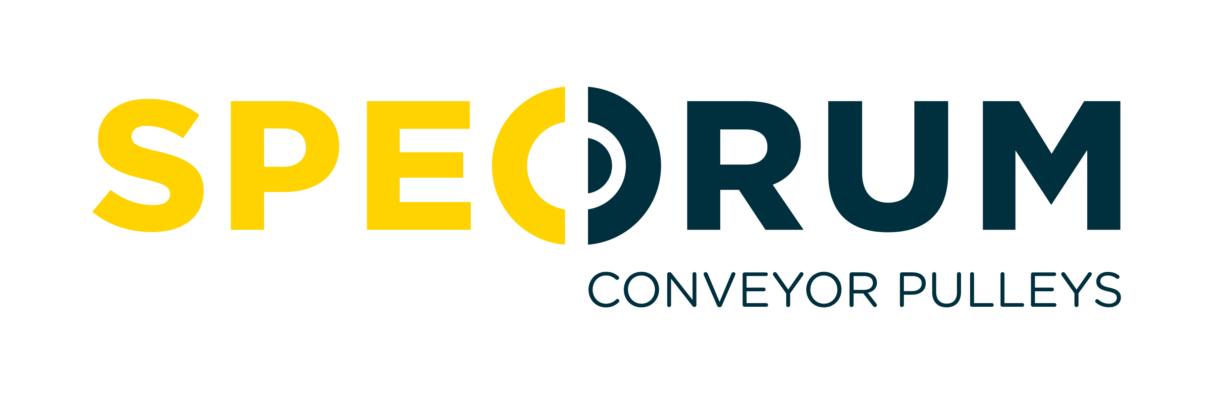
COMPANY: | Specdrum Ltd
JOB TITLE: | Despatch Quality Operative
REPORTS TO: | Pulley Quality Control/ Despatch Supervisor
JOB PURPOSE: | To oversee and monitor quality controls relative to Pre-Despatch Inspection (PDI) and complete quality inspections of China supplied pulleys.
DUTIES & KEY RESPONSIBILITIES:

- Ensure Despatch Operatives check technical drawings for pulleys on their assigned picking list.
- Maintain close vigilance over Despatch Operatives as they complete PDI actions.
- Ensure required pre-despatch checks have been completed fully and accurately prior to despatch.
- Check quality inspection documents are completed, with particular attention paid to the following:

- Pulleys distributed within Northern Ireland/Republic of Ireland:
- All pulleys with locking elements have been torqued to the correct specification.
- All pulleys are free from mechanical damage to the Shaft, Pipe, Lagging Etc.
(iii) All pulleys have had basic assembly dimensions checked.
- The correct pulleys have been picked and that quantities are correct as per customer order.
- The shafts of the pulleys have been protected against corrosion.

- Pulleys distributed outside Northern Ireland/Republic of Ireland. As above plus:
- All features including drill and tap, keyways, shaft grooves, radius etc. are present and correct.
(ii) Bearings can be freely fit on shafts.
- Lagging pattern and thickness is verified.
- Shaft etching is complete if required by the customer.

- Handle, transport and store component parts as per training and instruction.
- Use and maintain work equipment correctly & safely, and keep a well organised workstation.
- Conduct necessary quality inspections on all incoming pulleys from China suppliers, add quantities to stock data and report any issues identified.
- Complete daily pre-use safety checks to ensure all work equipment is in good working order, and report any faults to the Despatch Supervisor.
- Ensure all procedures are adhered to and necessary records i.e. production, quality and health & safety are completed correctly and submitted as required.
- Provide cover in the absence of the Despatch Supervisor, ensuring goods are ready for despatch to meet with delivery targets and make decisions regarding work priorities.
- Any other duties, within reason and capability, as agreed with Quality Control/ Pulley Production Manager.

PERSON SPECIFICATION:
Criteria | Essential | Desirable
Qualifications/Attainments | - Good standard of education to GCSE level or equivalent | - Valid Forklift Truck licence
Relevant Experience / Knowledge | - Previous experience of undertaking quality inspections of manufactured products | - Previous team leader/supervisory experience within a high-volume manufacturing environment.
Skills and Competencies | - Ability to read technical drawings  - Strong organisational and communication skills, including the ability to listen  - Ability to work within a team and in an environment that has constant changing priorities  - Customer focus & attention to detail  - A strong work ethic & drive for results | - Operational use of Cranes, Abrasive Wheels, Air & Hand Tools  - Ability to use measuring tools

